logo

8.11.2021

Table of content

1. Information about our team 2

2. Recap 2

2.1 Main goal 2

2.2 Tasks 2

2.3 Realisation (apps and language that we used) 2

3. Structure 3

3.1 Structure of the files 3

3.2 Structure of the functions 4

3.3 Block scheme 5

4. Summary 5

# Information about our team

|  |  |  |
| --- | --- | --- |
| Name | Class | Roles |
| Petya Petkova | 10 V | **Scrum Trainer** |
| Dimitar Grudov | 10 B | **Back-end Developer** |
| Vesela Dekova | 10 A | **Front-end Developer** |
| Kameliya Yaneva | 10 G | **QA Engineer** |

# Recap

## Main goal

Our main goal was to make a maze game with C++, using multidimensional arrays.

## 2.2 Tasks

1. We assigned roles.
2. We collected information about the task.
3. We wrote the code.
4. We made presentation, documentation and README.md.
5. We made a QA documentation.

## 2.3 Realisation (apps and language that we used)

1. Apps, that we used:

* **Teams** and **GitHub** for communication and team synchronization.
* **Visual Studio** for writing the code.
* **Giphy** for making the logo.
* **PowerPoint** and **Word** for the making of the presentation and documentation.
* **Excel** for the making of the QA documentation

1. Programming language(s) that we used:

* **C++**

# Structure

## 3.1 Structure of the files

## 

|  |  |  |
| --- | --- | --- |
| № | Name of the file | What is this file for? |
| 1. | Main.cpp | Connects all the files together |
| 2. | menu.cpp | Contains the code for the front end and the menu |
| 3. | levelOne.cpp | Contains the code for the first level of the game |
| 4. | levelTwo.cpp | Contains the code for the second level of the game |
|  | levelThree.cpp | Contains the code for the third level of the game |
| 5. | menu.h | Header file for menu.cpp |
| 6. | levelOne.h | Header file for levelOne.cpp |
| 7. | levelTwo.h | Header file for levelTwo.cpp |
| 8. | levelThree.h | Header file for levelThree.cpp |

## 3.2 Structure of the functions

## 

|  |  |  |
| --- | --- | --- |
| № | Name of the file | What is this file for? |
| 1. | void frontEnd() | Prints welcome when we start the game |
| 2. | void color(int color) |  |
| 3. | void menu() | Calls the menu |
| 4. | int gotoxy(int x, int y) | Places cursor at a desired location on screen |
|  | void printMazeOne() | Prints the maze for level one |
| 5. | void changeLevels(string answer) | Asks you if you want to go to the next level when you finish with the previous |
| 6. | void levelOne() | Makes the object move in the maze for the first level |
| 7. | void printMazeTwo() | Prints the maze for level two |
| 8. | void levelTwo() | Makes the object move in the maze for the second level |
| 9. | void printMazeThree() | Prints the maze for level three |
| 10. | void levelThree() | Makes the object move in the maze for the third level |

## 3.3 Block scheme

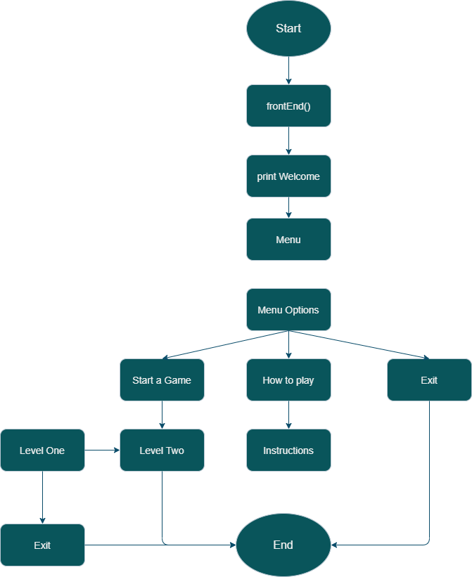

# Summary

In this school project we learned how to work in team and how to manage our time better. We learned new things about multidimensional arrays and QA documentation and understood how to work better with header files.